RINGS-A000-EUR-Rome-Legion-Legio VII Gemina

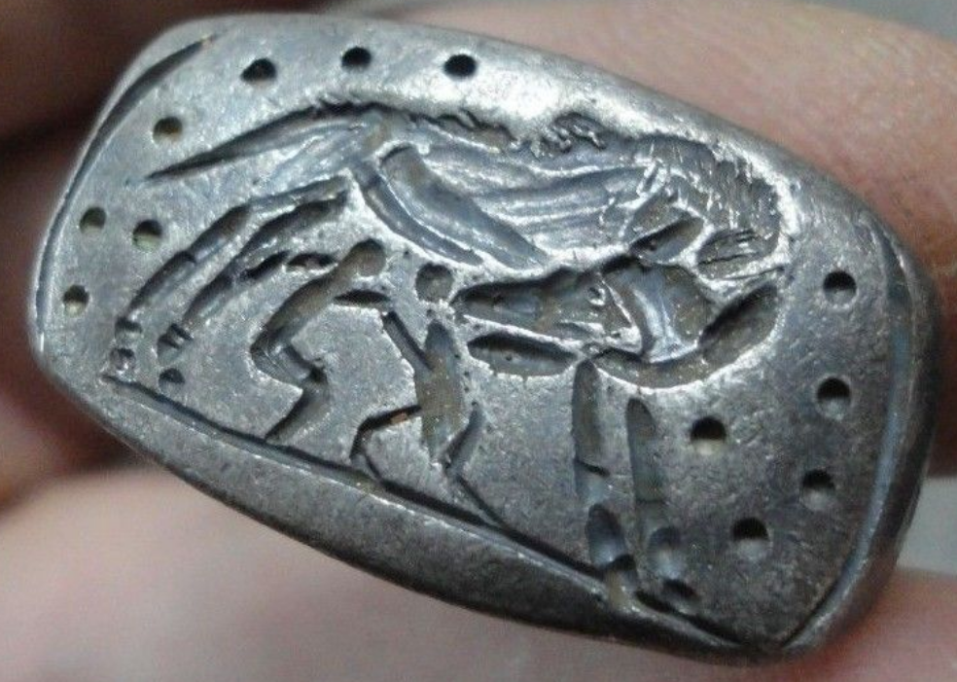

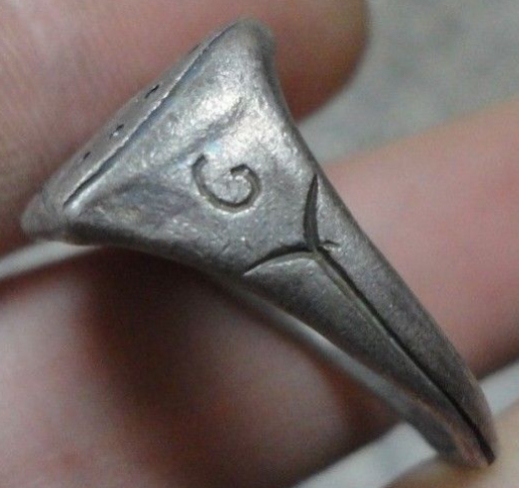 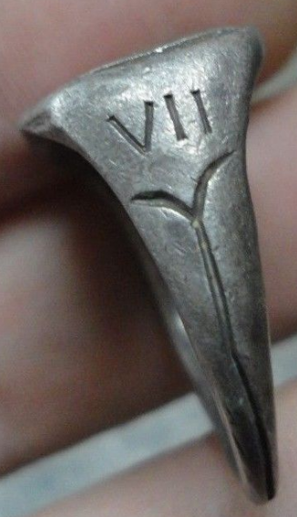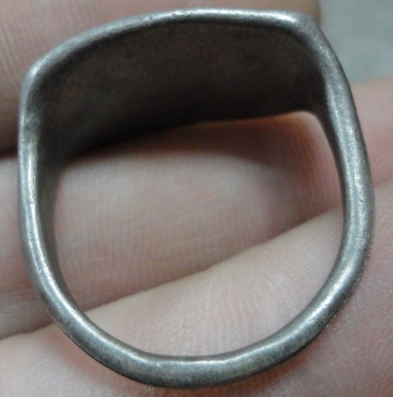 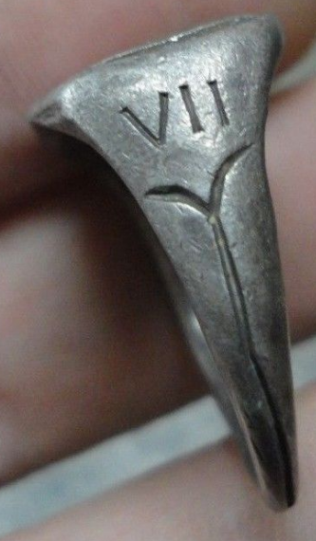

Legio VII Gemina

Legio septima Gemina (properly Geminia: Latin for "The Twins' Seventh Legion") was a legion of the Imperial Roman army. It was founded in AD 68 in Spain by the general Galba to take part in his rebellion against the emperor Nero. "Gemina" means the legion was dedicated to **the legendary twin founders of Rome, Romulus and Remus, who were suckled by a she-wolf**. The legion was deployed the city called Legio (modern-day León, Spain) in AD 74 and remained in Hispania to the end of the 4th century.

ANCIENT ROMAN SILVER LEGIONARY SENATORIAL RING INSCRIBED ' SHE HWOLF - G - VII '

Wearable <> 11.50 grams

INTERNAL DIAMETER : 23.00mm = 0.92"